
SPRING BREAK TRAINING CAMP
March 29th ,2022
LIMITED AVAILIBILITY!
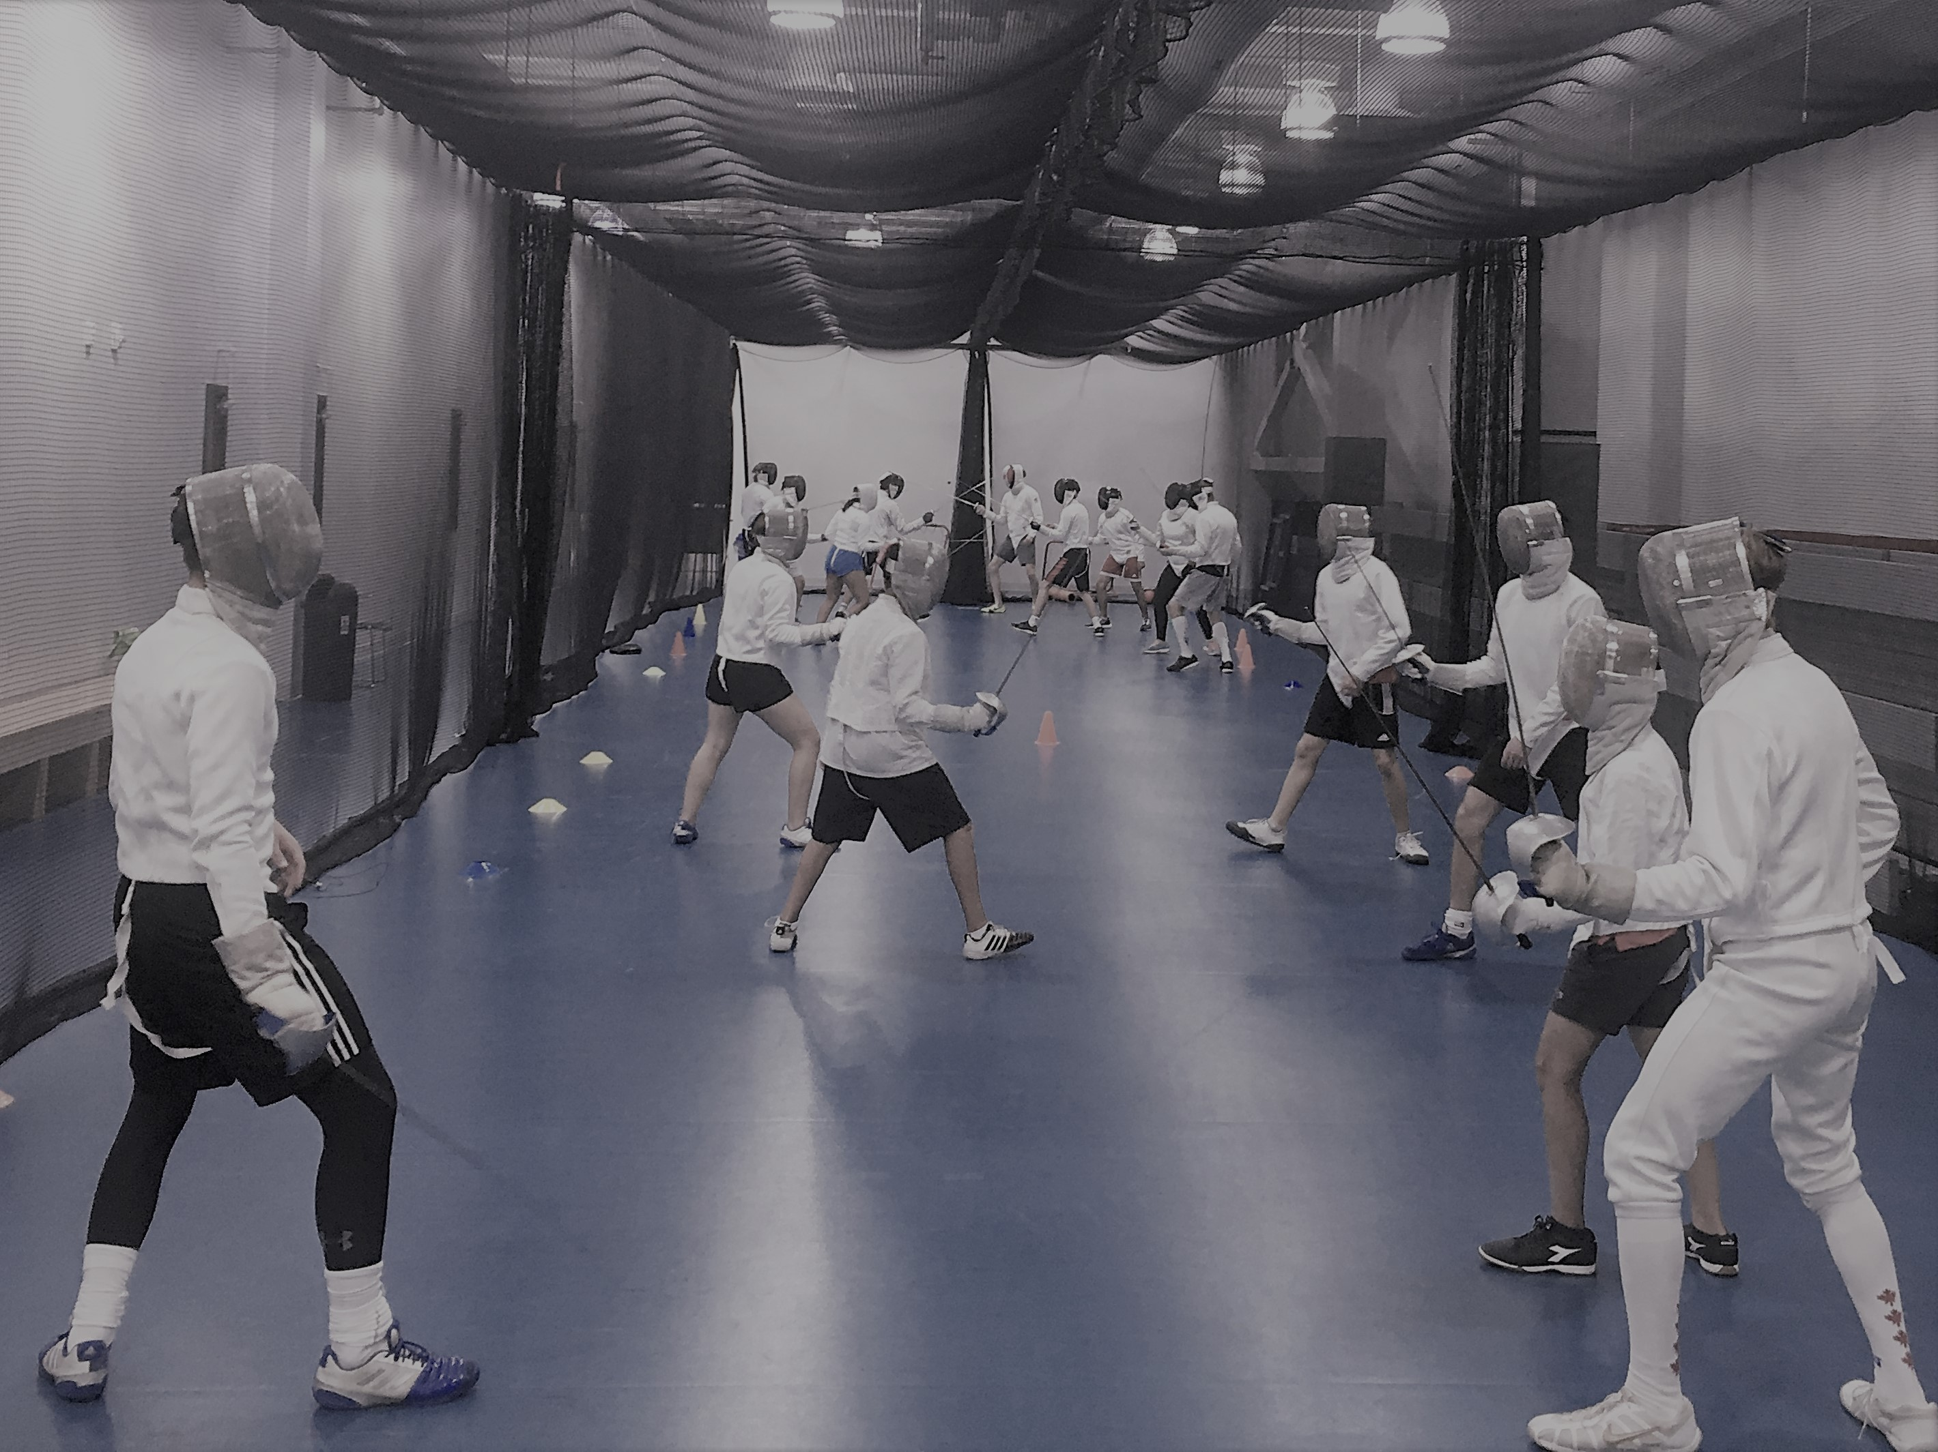
With the spring break coming soon, you have the opportunity to let your kids to do the sport they love and get improve their fundamentals. Here at Manitoba Fencing we offer fencing during spring break. Our camp is run by the most experienced coaches in the province.

Daria Jorquera Palmer, Lightning Fencing Head Coach, and Provincial Team Assistant Coach.
Several Years Canadian National Team Member and Medalist at a lot of national and
international competitions.
Xavier Slocombe, Rapier Fencing Sabre Coach
Zacharia Bounachada, Rapier Sabre Fencing Coach.
Noah Merza, Lightning Foil Coach

Venue: Qualico Training Center, 145 Pacific Avenue, Winnipeg

Who? All fencers who have less than 2 years fencing. Provincial Team Members are welcome

Weapon: Foil/Sabre/Epee Age: 12 and under
Program:

- Prepare the next Canada Games Generation
- Learn to train
- Working on your fundamentals
- Fun activities
Fees: 50 $ for a day

CAMP SCHEDULE

Time | 9:00 - 10:00 | 10:00 - 11:00 | 11:00 - 12:00 | 12:00 – 13:00 | 13:00 - 15:00
PROGRAM | Introduction  Group Warm up-Team Sport –  Footwork- | What is Technic?  Why we need technic?  Drills in Pairs (working on key technic in your weapon). | Team Competition  (Relay) | Lunch / Free Activities  Basketball/Soccer | How to run an Individual Warm up?  Basic Tactical Preparation  How to analyse?  What to watch?  What to do?  Group lesson with the coaches.  Free Bouting.  Group Stretching

Manitoba Fencing Association
sPRING BREAK training camp

Registration Form

March 29, 2022

Name ……………………………………Age …………………..Sex…………

Address………………………………………………………………………….

City………………………………………Province…………Postal Code……….

Phone (….….)……………………………Email………………………………..

Club Affiliation………………………………………………………………….

Health Care Number/Medical Insurance information…………………………..

Allergies/Special Requirements…………………………………………………
…………………………………………………………………………………..
…………………………………………………………………………………...
…………………………………………………………………………………..

Classification Foil [……..] Sabre [………..] Epee [………]

Make cheque or money order payable to:
Manitoba Fencing Association

Send registration form to:
Manitoba Fencing Association
145 Pacific Avenue, Winnipeg, MB
R2B 2Z6

Payment must be received by March 18th, 2022.

