Manitoba Fencing Association

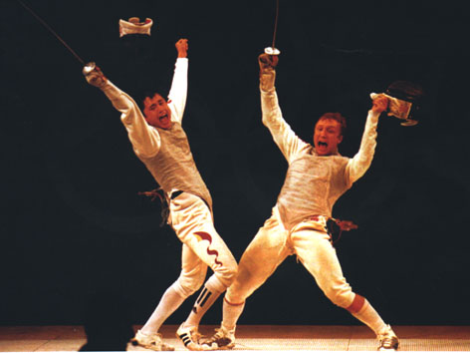

WHO GOT THE POINT?

Referee Development

By Ayach Bounachada
International and 2008 Olympian Referee.
(FES)

- Description:
-This program is designed to prepare individuals for officiating opportunities, as well as to allow for opportunity to seek certification at the Provincial level in all weapons. Theoretical teaching as well as practical training will be incorporated.

- Eligibility:
-Must be at least 12 years old.
-Must have at least six months of fencing experience.
-Open to coaches, athletes, and parents

- Certification:
-Certification involves 2 components:
1) Theory examination
2) Practical examination

Note: Both parts require a grade of 70% or more to pass.

i) Theory examination:
-General Fencing knowledge of rules
-Specific knowledge of a single weapon (of your choosing)

ii) Practical examination:

-Only candidates who succeed the theory exams can be eligible for this part.

The candidate must officiate at the 4 local competitions where he/she will be observed by an evaluator. Program participants will receive feed back for his/her work following each tournament.

A regional tournament, such as the Militia Open in Saskatchewan, may also be a required tournament to officiate at the end of the year and will be included in the syllabus if applicable. The overall practical performance at these tournaments will decide the result.

iii) Characteristics of practical evaluation: See details in the Evaluation Document

a. Attitude of the candidate: /10
b. Decision: /40
c. Hand signals: /10
d. Applying the FIE rules: /20
e. Phrase d’armes: /20

In case we use the Evaluation just from Video Arbitrage; the candidate have to:

- Wear a classic suit for his or her Exam
- Face the Video Arbitrage that will be shown on the screen.
- The action will be shown once in a real speed, then the candidate has only 10 seconds to review it on the slow motion.
- The candidate will have to ref 4 to 6 bouts of 15 hits.
- The candidate have to ref a specific fencing situations.

- Requirements
  - Practice at your club at least once a week.
  - Opportunity to practice at the provincial level,
(A good referee has to keep in contact with the practise - more they practise better they will be.)
  - Officiating at least two camps with the provincial team (Sundays only) will be required.

5- Teaching Plan:

The course is spread out over the year, from November- April of the year.

CONTENTS | CHARGE
Theory | 04 hours
Practical using Video Arbitrage | 06 hours
Practice (see requirements.) | - Training at club  - Provincial team’s training  - Training at Camps
Theory Exams | 02 hours
Practical Exam | - Local competitions or Online with Video Arbitrage.  - Golden Boy Competition  - Regional competition

Areas covered in the refereeing courses

- Classification of fencing actions.

- Terminology

- Characteristics of the three weapons.

4. Piste.

- Formula of competitions.

- Offences and their penalties.

- Refereeing and judging of hits

- Video Arbitrage

- Practicing

