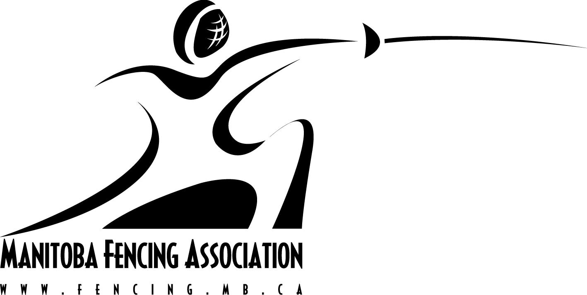
MANITOBA FENCING ASSOCIATION’S
2023-2024 Officials Training Program

Program Conductor:
Provincial Coach/Technical Director, Ayach Bounachada
International Referee three weapons
Officiate over 70 finals at WC, Grand Prix, World Championship, Pan Am and Olympic Games
Olympian Referee 2008

Program Overview:
The program is to train individuals to become knowledgeable and competent fencing referees.

Program dates:

December 7th 2023 From 6:30 to 8:00 pm Theory
December 14th 2023 From 6:30 to 8:00 pm Theory-Parcticum
January 4th 2024 From 6:30 to 8:00 pm Theory-Practicum
Feb 11th, 2024, From 9:00 to 4:00 pm Practicum
March 24th, 2024 From 9:00 to 4:00 pm Theory/Practical Evaluation

The theory and practical sessions will be conducted in person.

Note: Schedule may be subject to change

Program Cost: $120 per person (this includes registration fees and course materials)

Registration Deadline: December 1st , 2023

--------------------------------------------------------------------------------------------------------
Registration Form

Name:

Address:

Phone:

Current level of Official Certification (if applicable):

Signature:

Payment:
e-transfer payments can be sent to fencing@sportmanitoba.ca

*Cash or cheque payments can be sent to:

Manitoba Fencing Association
145 Pacific Avenue
Winnipeg, MB R2B 2Z6

